**Date:18.8.22**

# Program 3: To perform Bubble Sort

Code:

#include <stdio.h>

int main()

{

int a[20],ub,lb=0,mid=(lb+ub)/2,value,size,temp,i,j;

printf("enter size of array:");

scanf("%d",&size);

printf("enter array elements:");

scanf("%d",&a[i]);

for(i=1;i<size;i++)

{

scanf("%d",&a[i]);

}

for(i=0;i<size-1;i++)

{

for(j=0;j<size-1;j++)

{

if(a[j]>a[j+1])

{

temp=a[j];

a[j]=a[j+1];

a[j+1]=temp;

}

}

}

printf("the sorted list is:");

for(i=0;i<size;i++)

{

printf("%d\n",a[i]);

}

return 0;

}

Output:

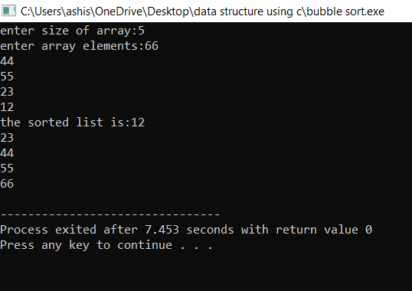

# Program 4: To find 2nd largest element in an array

Code:

#include<stdio.h>

int main()

{

int arr[10],lar_el=0,Second_lar_el=0;

int size,i;

printf("Enter the size of array:");

scanf("%d",&size);

printf("Enter the array elements:\n");

for(i=0;i<size;i++)

{

scanf("%d",&arr[i]);

}

for(i=0;i<size;i++)

{

if(lar_el<arr[i])

{

Second_lar_el=lar_el;

lar_el=arr[i];

}

else if(Second_lar_el<arr[i])

{

Second_lar_el=arr[i];

}

}

printf("The largest element is:%d\nSecond Largest element is:%d",lar_el,Second_lar_el);

return 0;

}

Output:

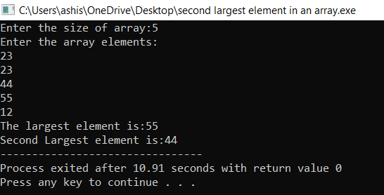

# Program 5: To calculate length of a string

Code:

#include<stdio.h>

int main()

{

char a[20];

int i,length=0;

printf("Enter the string:");

scanf("%s",&a); for(i=0;a[i]!='\0';i++)

{

length++;

}

printf("length of String is: %d",i);

}

Output:

